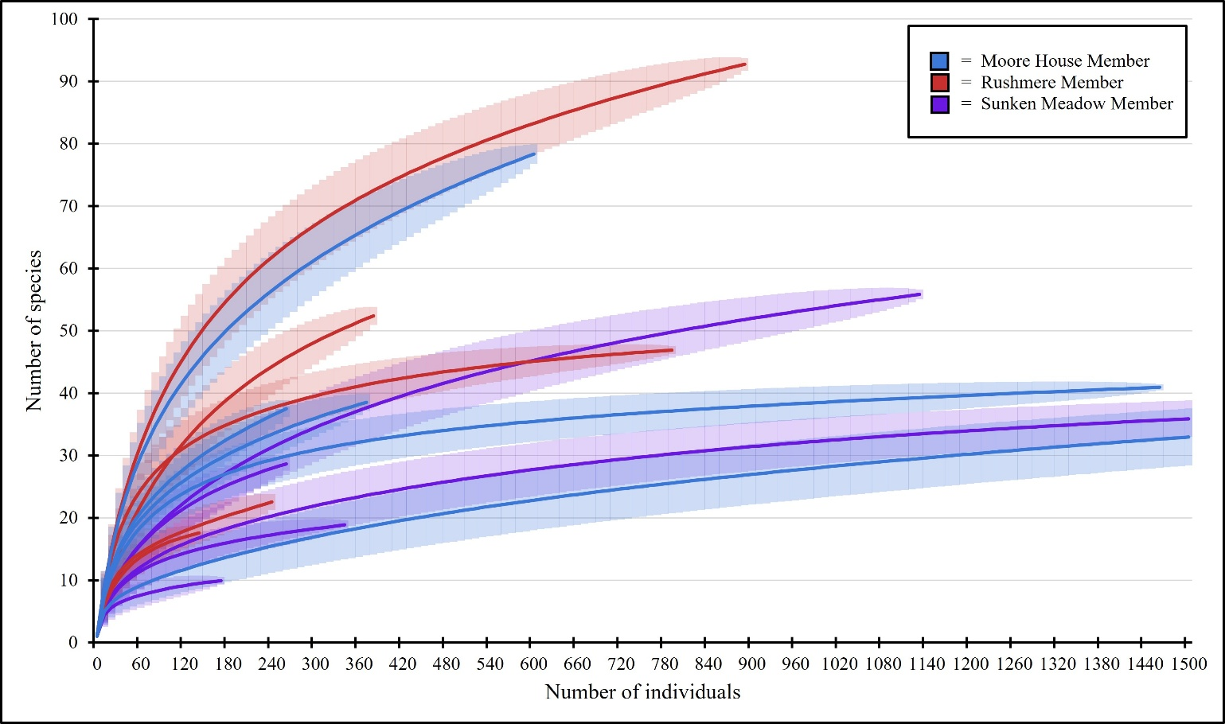
FIG. S1. – Raw data rarefaction (± 95% CI) of species level data. Curves end at the total size of the sample or at 1500 individuals if sample sizes were very large.

